The concept of an Action Cycle in negotiation practice
Dr Deborah Goodwin

One day a clam opened up to sunbathe for a while on a beach. Suddenly, a snipe stuck its beak into the clam to try and eat it. The clam closed its shell immediately and trapped the snipe’s beak. The clam refused to open up, and the snipe couldn’t remove its beak. Neither of them would make a move to try to break the deadlock. Finally, a fisherman came along and bagged them both for the cooking pot.
‘The Snipe and the Clam’ a Chinese folktale
“I win, you lose”; how often do we hear that? Occasionally overtly, but more often this is the implicit approach to a conflict or interaction where stakes are high. It is hard to resist the feeling of winning at least; at most, it delineates the tactics employed and the strategies implemented throughout an encounter. But just how effective is this perception? Doesn’t it constrain rather than liberate the practitioner? In particular, how do we perceive useful problem solving and resultant conflict resolution in practical terms?
As Sun Tzu stated:

Those who are skilled in executing a strategy,
Bend the strategy of others without conflict;
Uproot the fortifications of others without Attacking;
Absorb the organisations of others without prolonged operations.

In modern parlance Sun Tzu is alluding to the power of understanding the other in order to influence, and then change. His thinking is not that of overt zero-sum but of influence tactics that subtly undermine the other, even though these words are written in the ‘Art of War’. But what is ‘influence’? Isn’t it just another description for cynical manipulation and so another way of ‘winning’? And, most importantly, how should we train influence practitioners in an effective, but user-friendly way?
Wars are very much like road accidents. They have a general and a particular cause at the same time…the police and courts do not weigh profound causes. They seek a specific cause for each accident-driver error, excessive speed, drunkenness, road conditions. So it is with wars.
A.J. P Taylor
Of significant importance to field negotiators is a response to their question ‘So what do I do? Academic theory concerning negotiation and influence plays an important part in underpinning practical application, of that there is no doubt. However, my own professional experience in this field since 1994 has repeatedly revealed that practitioners want mental ‘hooks’ to ply their trade as effectively as possible. They also find the inclusion of a pertinent and memorable framework very useful in both their training and their field application.
Theory is always simpler than reality. Even when it seems terribly complex, it is still simplistic, as compared to [sic] the range of factors, operating as conditions, as means, or as ends in any actual concrete situation.
Viner’s comments above help to reinforce the concept that designs for negotiation training and frameworks ought to be diverse in nature, content and application. For example, business and political negotiation training tend to follow an established pattern with a stress on behavioural and personal skills to use during the process, and a lesser emphasis on interpersonal/relational interaction factors, (which might indicate a personal weakness), and which are less open to generalisation. Many training courses are scenario and context non-specific, they have to be, otherwise they would tend to become irrelevant to many delegates, and concentration on personal communication and outcome expectations tend to be common denominators in such a skills based training course. But this is ineffectual for negotiators training to negotiate out in the field.
Negotiation is essentially a conversation with a purpose. I maintain that it revolves around the strategies of listening and watching (the expressed want stage), thinking (identifying interests) and responding (ALS and influencers), in turn. Deceptively simple as these responses seem, working from an informed position concerning one’s own approach and that of others is more effective than pure intuitive reaction or pure advocacy. Competitive antagonism in negotiation is far less effective than enquiring and influencing.
Even expert negotiators employ tried and tested strategies to the way in which they influence and negotiate, supplemented with their experience of previous prototypical situations. However a novice negotiator does not have recourse to similar experiences and can only build up a personal pool of knowledge about negotiation slowly. But by using recommended techniques and recognising key psychological and behavioural factors it is possible to engage in effective and fruitful negotiation when one is still a novice. It is a skill that can be developed and honed like any other, particularly if we are familiar with predictable human motivations and behaviours.
Importantly, these strategies revolve around obtaining movement in the process without an overt sense of imposing a loss on the other and thus a sense of failure or belittlement. As Kahneman and Tversky (1979) stated: “…losses loom larger than gains”.
If you and I are negotiating then I will have in mind ways in which I can listen to your arguments and wants, understand what you value and care about, but then I will seek to alter the position you are taking by using influencers that will be attractive to you; more attractive than your original arguments. How can this movement be modelled?
I propose that this action cycle can be represented and explained in the following way:

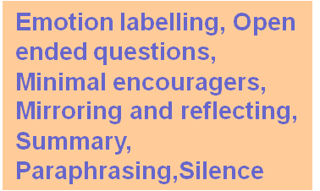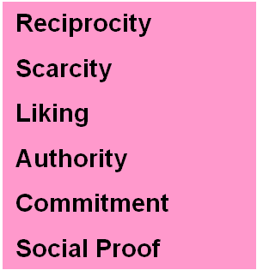
+ ABC motivators
Changed through

Interests
(what we care about, value, need)

Active Listening Skills

Influencers
(eg Cialdini)
Informed by
Discovered through
Listening Watching

Responding Thinking
Expressed want
(position taken in a negotiation)

(Goodwin) Action Cycle

Interests are what we care about, value or need. They can be explicit or implicit (such as feelings), overt or covert; but they define what is making us think, how we behave and make decisions. They underlie the expressed want, or position, we take in a negotiation. If you can suss interests (and this includes your own) then you can shape ideas and options that will play to those interests and will be more effective than just beating the other party.
So, for example, if a guard at a checkpoint says ‘You can’t go through’ then that is his position; his expressed want. But why is he saying this? It might be because he has orders, or he is unsure what to do about you, is on his own, is aware of other soldiers around him and that they are watching what he is doing, is trying to carry out the wishes of a third party who isn’t there, wants to mess you around, wants to delay you for some reason, is frightened of you, and so on. Through Active Listening (ALS) you should be able to start to identify what is actually making this man tick. Why has he taken this position? By delving into his interests (what he cares about, what he values, what he needs) it might be that we start to hear a powerful interest of fear about the consequences of letting you through, for example. In this case you would need to provide suitable reassurance about his personal safety, save his face (as he is very unlikely to openly state he is scared), build liking, trust, empathy and authority, and start to change his expressed position of not letting you through.
So below every expressed position are layers of interests that inform that expressed want or behaviour. It is not possible to effectively change someone’s position unless you identify WHY they have taken it.
One peacekeeper nearly got himself killed by dumping a cup of water on the ground which had been offered to him by a civilian. The act was taken as a grave insult, and the incident provoked the closest thing we came to a massacre in the course of the tour.
— Comment by a Major serving with UNPROFOR 1994

Listening

Becoming an effective negotiator does not mean that we have to be able to speak at length and verbally dominate any encounter. Far from it; expert negotiators aim to speak for only 10-20% of the time if possible. This is pretty ambitious if you are new to the technique. Even so, it is best to aim to speak for no more than 30-40% of the time. So, how do you stop yourself from butting in all the time?

If we are speaking then we are not listening; and listening provides us with masses of information about the other person, the problem, their motivations, their needs and wants, their framing, their tactical response if the negotiation goes badly, and possible resolutions. It is very tempting to leap in to defend, counter-argue or challenge the other party in a negotiation. But if you are in a situation where your main aim is also to de-escalate tension as well as attempt to find a mutually agreeable solution, then active listening is your ally.
Active listening skills are based around a set of techniques which work in two ways. Firstly, they encourage the other party to keep talking to you (and we’ve already said how much you can learn if they keep talking). But they also help to make you sound more engaged in what is going on, empathetic and in control, plus they give you thinking time.

Active listening factors:
Emotion Labelling: a verbal statement of the emotions you are hearing
Paraphrasing: their meaning in your words
Mirroring/Reflecting: echoing single words or short phrases to make them explain more
Summary: a re-statement of main points from time to time
Open Ended Questions: What, Why, How, When…?
Minimal Encouragers; short follow ons: ‘Ummm’ ‘I see..’ ‘Tell me more…’
Effective Pauses: use of silence to promote a response
‘I’ messages: taking the blame on yourself and save face : ‘I’ve misunderstood..’ ‘I am a bit slow on the uptake today please would you explain further…?

Why do these techniques work? Think of active listening skills as a cocktail you can mix each time you negotiate. Use them sparingly and in proportion to each other because if you are heavy handed then the result can be distasteful.
Emotion labelling taps into the human need to have others understand how we are feeling. Unexpressed feelings can fester and cause deeper problems to all concerned, so if you think it appropriate then a quick response such as “ I can hear that this is really worrying you, so what would you like to happen?” is a useful mix of an emotional label and an open ended question. This is likely to make the other party feel that you have listened and understood their personal emotion (i.e. worry) and are also keen to hear what they suggest without immediately imposing a solution. Paraphrasing and summarising also help the other party to know that you have understood their point and, if you have got it wrong, then they will correct you, and you are now better informed. If you are trying to sustain a 30-40% verbal input in the negotiation then use mirroring and reflecting, minimal encouragers and pauses just to nudge the person into saying more. ‘Tell me more…’ is a great verbal nudge, and never be afraid to use silence after you have posed a question for example; let them fill the ‘uncomfortable’ pause, not you. If you want to save their ‘face’ then use an ‘I’ message where you take any blame and thus avoid their embarrassment. For example, if they have spoken in a confused way then say something like “I’m sorry but I didn’t catch that; could you explain it to me again?” rather than ‘You just aren’t speaking clearly and you are very hard to follow”.
There is a Chinese proverb that roughly translates as ‘Point at the chicken to scold the dog’; and this sounds rather odd to Western ears. However, it makes the case about ‘face’ very clearly; the chicken won’t be embarrassed because everyone knows he is blameless, but the dog doesn’t lose face because he hasn’t been pointed at, and so won’t bite you back either.
A powerful example of how a potential zero-sum encounter was rescued by an active listener is an event that occurred between President Carter and Prime Minister Begin during the Camp David talks. After thirteen hard days it looked like the talks were breaking down. Instead of threatening, Carter remembered a request made by Begin for signed photographs of the three leaders that he could give to his grandchildren. Carter personalised each picture with the name of a Begin grandchild, and during a stalemate he handed the photos to Begin. Begin saw the names of the children on each photo and said each name out loud, with mounting emotion. He and Carter then talked quietly about grandchildren and the prospect of war. This was a turning point in the negotiation, as later that day the leaders signed the Camp David Accord.

Watching
Useful elements to watch out for here are the motivations of the other party and what seems to be influencing them.
Recall the idea of core ‘ABC’ human motivators: a sense of Achievement, Belonging and Control. Each of these factors underlies many of the behaviours and responses that people make, and negotiating is no different. If someone is preoccupied with a sense of achievement in a negotiation then it is likely that they will seek to set overt goals and deadlines so that they can go away with a result. We might also observe them acting in more of a self-interested way because they want to be effective personally, rather than for a third party, and so they may well use ‘I’ a lot in the exchanges and want to publicise any agreement reached as quickly as possible. Strategies to employ with a party pre-occupied with achievement are open questions, summary and using any deadlines set positively, i.e. shaping the time available to act co-operatively to agree a mutually viable solution.

Belonging can affect negotiators immensely. They might not be negotiating for their own ends but for those they represent. They want to personify their group needs and succeed for their group and so are unlikely to make any individualistic maverick decisions, and to be quite cautious in their style. If they are not the ultimate decision maker they will be very reticent to make any agreements without talking to others outside the negotiation, and you will need to allow for frequent breaks in order for this to happen. A sense of belonging can also have a negative impact on the way in which a military negotiator is perceived; you may be an outsider or alien to the group culture and ethos that they represent. In this case, you need to build rapport and empathy through ALS.

The negotiator who is swayed by a strong sense of control may seek to dominate the exchange. Control could be represented in two ways: personal power and fear of the unknown. Personal power issues are expressed in competitive behaviour in the negotiation; defensive and offensive statements directed at you and what you represent, and you’ll hear plenty of phrases that start ‘I want…’, ‘I need…’. ‘I’ messages could come in useful here if you do not want to antagonise, as would an implicit recognition that there might be some conflicting emotions at play here. Are they behaving like this because they are fearful of the future, although they will never express this to you overtly? Put a silent emotion label on their behaviour and bear this in mind in the way you shape any options generated.

People are often influenced by elements that transcend personal motivations, culture and overt recognition. Cialdini proposed that we are all subject to broad factors that can influence the way we think and behave, and it is useful to be aware of these when we are negotiating.

Cialdini’s Influencers:
Reciprocity
Scarcity
Authority
Liking
Social Proof
Commitment and Consistency

Reciprocity is the notion of give and take. There is an implicit drive in us to respond to someone positively if they have given us something; we want to reciprocate. For example; if you are invited to a colleague’s home for a meal you feel you should take a gift with you by way of thanks. If someone turns up empty handed we tend to think that person is mean or churlish. If you are able to give something that is fairly inconsequential to you early in a negotiation, then it is likely that the other party will want to reciprocate. You can also use reciprocity in an encounter if you want to slow things down; get a brew on, get cigarettes out (it’s amazing how many non-smoking operational field workers carry cigarettes) or share food.

Scarcity refers to the feeling of loss we experience if we sense that we might miss out on something. We hate it if others might profit from an opportunity that could pass us by. You can use scarcity in a variety of ways; for example: you could refer to your actual presence in scarcity terms: ‘Look, I am only going to be here for the next couple of hours and I don’t know if the next commander will be willing to talk to you in the same way as me, so how about we sort this out?...’ It’s a take it or leave it approach.
We all tend to expect authority figures to know more, be trustworthy and worth listening to. Advertisers use this tactic all the time when they attempt to persuade us through using people in ‘white coats’ to endorse their products.
Liking influences us at a deep level. It revolves around both the ability to find the other party appealing in the sense of ‘being like me’ and thus part of my group, and also a more emotional response to you. We will all engage more with people we like and who we feel understand us. This is where your ALS will come in useful once more as you try to build rapport and empathy. Also, if it is appropriate, then to humanise yourself in your exchange with another party; talk soldier to soldier, man to man, woman to woman, parent to parent and so on, as it might build empathy still further.
We are essentially herd animals, dislike being solitary, and seek to be part of our respective groups. Therefore we are prey to the Social Proof effect. This is when we see how everyone else is behaving and then are convinced that we must behave in the same way. “If everyone else is doing it then I ought to be too”. Very few people act in a totally individualistic way in this world and seek to think and behave in ways that completely deviate from all human norms and values. You could use this impetus when you negotiate by saying ‘…well, everyone else has signed up to this agreement and you are the only one who hasn’t. Is this the way you want it to be?’
Finally, the issue of commitment and consistency. If we put something in writing, if we give a public promise, if it is on the record, then we are unlikely to break that commitment. If you happen to say to a friend that you aim to complete your run in a certain time, then you will do your utmost to complete the run in that stated time, even if it kills you. It’s because you’ve given a public promise, and publicly set expectations. If you don’t honour this, then you will feel a failure. So, in your negotiations see if you can get them to write an agreement down and sign it, or publicly go on the record with their agreed actions. It is harder for them to renege if you do so. All of this ties in with consistency issues also, because if you make promises and are seen to carry them out then that will build trust and respect, and help you in further encounters and those who are deployed after you.

Thinking and Responding
Recall the Rational Problem Solving space at this point: this concept revolves around the notions of the comprehension space, the problem space, option generation and the decision making space. You can use this process to work out the steps you need to take in a negotiation also. For example: 1. What is the key issue in the negotiation? 2. What else is going on and affecting what is happening? 3. What are the likely options here? 4. Which options are the most viable and likely to succeed?
Using all of the techniques above, you are now ready to respond; Active listening will help you to shape your knowledge about the person and the situation, you have identified what is motivating and influencing them, and their core interests. Responding should now be the simplest part of the entire negotiation process as you have been identifying and planning all the time and generating options internally. Using all the information you have gathered from the three stages above you now shape your verbal response to cater for each of these factors. (The unskilled negotiator would tend to leap immediately to this stage of the process and so fail to rigorously interrogate the information to hand, and thus be more open to failure)
Keep re-assessing and shaping your responses as the negotiation continues and as you continue to learn more from their responses and behaviours. It is more than likely that you would have to implement the Action Cycle many times in the same encounter in order to listen, understand and affect in the best possible ways.
So how does this Action cycle fit into wider notions and applications of diplomacy and strategic dialogue?

…Miscalculation and misunderstanding and escalation on one side bring a counter-response. No action is taken against a powerful adversary in a vacuum… The final lesson of the Cuban Missile Crisis is the importance of placing ourselves in the other country’s shoes…Thus if hostilities were to come…[it was]…because of our failure or their failure to understand the other’s objectives.
Robert Kennedy

Referring to Curle’s depiction concerning the resolution of asymmetric conflict for a moment, then it is possible to apply the Action Cycle to his ‘change’ box between conflict and agreement. He specifies making change, but not how to approach changing attitudes and relationships in any tangible sense. It can be argued that the Action Cycle could inform the ‘but what do we do?’ question explicit in his identified aim.
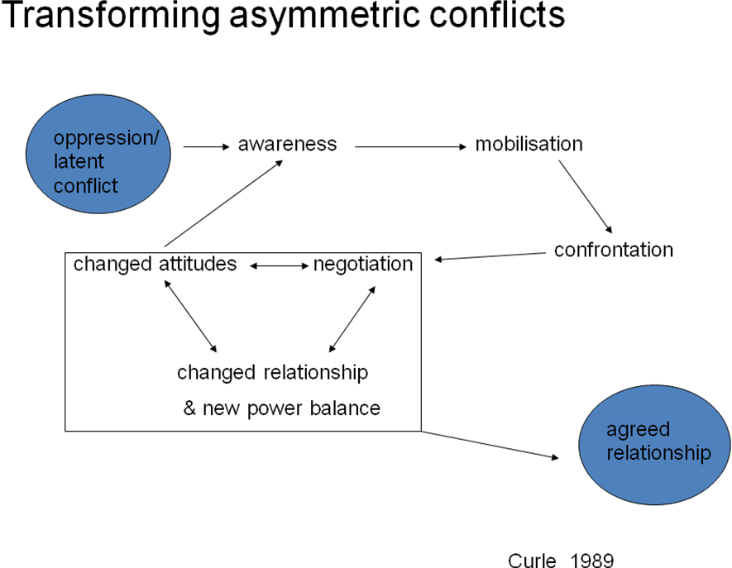

As Sarna also comments:
…worst case scenarios combine high risk factors with low organizational capacity…The task of incident commanders is twofold. First, the complex must be made simple…it also involves the gathering of intelligence to make the situation more understandable (i.e., less equivocal) and thus, hopefully, more manageable. Second, irrationality must be reduced to a point where problem solving becomes possible. As complexity is reduced and irrationality decreases, risk falls. Concomitantly, the likelihood of successful resolution rises.
Peter Sarna (1997)

The perception of personal risk during a negotiation is also very influential on the decision to either confront or yield, to explore or close down, and how one might be influenced or not (cf the Action cycle stages). This in itself impacts significantly on perceptions and behaviours in a negotiation and ought to be included in any representation also. For example, the traditional dual concerns model can be re-designed to model the variable risk threshold that affects both personal response and personal approach.

Yielding Problem Solving

Avoiding Contending
High
Concern about Other
High Risk

Risk threshold (mobile)

Loww
Low Risk
High
Low

Concern about Self

the amended dual concerns model (DKG)

It can be argued that it might result in three main perceived risks: image loss, position loss and information loss. These losses directly impact on status, power and dialogue issues. The size of the conflict to be resolved will also make yielding and problem solving seem unfeasible and risky and will heighten the frustrations that a party will have concerning the achievement of its own goals without the loss of status. In terms of the dynamics at play throughout these factors, the application of active listening in terms of judging the risk threshold of the other and oneself is paramount in order to assess whether influence can or should be applied at all.

Conclusion
Whilst some might baulk at providing a tangible and overt framework such as the Action Cycle, it can only be argued that many field practitioners state that they find the usefulness of such mental hooks pertinent and viable. Although it creates a construct of sorts, it is not restraining, as the field negotiator, especially as experience grows, will develop finesse and personal nuances in addition to these basic proven strategies. It can be used to establish the novice negotiator and to assist the occasional negotiator. It can be bolstered by context specific examples and exercises during any training; similarly it can reflect real environments in practice. It is a support, and a platform, from which one can strengthen personal skills. As one field operative powerfully said recently:
…The physical and mental pressures are known by many, and imagined by most, but the challenging circumstances within which you find yourself are not to be underestimated….I am now a believer in the application of principles cross the spectrum of the operational environment.

Further Reading:
Goodwin, Deborah The Military and Negotiation (2005) London:Routledge (also available in Chinese, Nov 2010)
Goodwin, Deborah About turn: Preparing the military negotiator in current conflicts (2010) Sandhurst Occasional Paper #1 (http://rmasteams.tafmisweb.tafmis.r.mil.uk/Academics/httprmasteams.tafmisweb.tafmis.r.mil.ukAcademicslibrary/Occasional%20Papers/Occ_Paper_1.pdf)
Cialdini, Robert. B. Influence:science and practice (2001) Needham Heights, MA:Allyn and Bacon
Fisher, R. and Ury, W. Getting to Yes : negotiating an agreement without giving in (1991) London: Random House
Zartman, I.William and Faure, Guy Olivier (eds) (2005) Escalation and Negotiation in International Conflicts Cambridge: Cambridge University Press

The views expressed here are those of the author alone, and do not represent the views of the Ministry of Defence or any other agency, organisation or individual.

Cited in Zartman, I.William and Faure, Guy Olivier (eds) (2005) Escalation and Negotiation in International Conflicts Cambridge: Cambridge University Press
Sun Tzu, “Engaging the entire system, 9 III” (trans R.L Wing, The Art of Strategy New York: Thorsens, 1997) p44
J Viner, Internal trade and economic development (Oxford:Oxford Clarendon Press, 1953) p1
Most major international companies provide in house training for personnel, and negotiation training courses are common. Details of general negotiation courses can be found in copious numbers on the Internet. [Henley Business School, Harvard, and many private training firms].
ibid p208
Definitions of ‘power’ are diverse amongst theoreticians. Some view power as a possession and thus something that can be distributed [see H.J.Morgenthau, Politics among Nations ((New York: Knopf, 1978)]. Others believe it can be a factor within negotiation which is likely to predict outcomes [see I.W.Zartman, ed., “International Organisation on Multilateral Negotiations”, Negotiation Journal,1989a (entire issue)]. ’Power’ has also been described as “the way in which actor A uses its resources in a process with Actor B so as to bring about changes that cause preferred outcomes.” Habeeb in W.M Habeeb, Power and Tactics in International Negotiation (Baltimore,Md.:John Hopkins University Press, 1988) p15. Theories such as these have tended to focus on the power advantage of one party over another, increasingly theoreticians are shifting the focus towards the moves within a negotiation which might be ‘powerful’. For example, the work of Fisher and Ury [see R.Fisher, and W. Ury, Getting to Yes:Negotiating Agreement without giving in (New York: Penguin, 1984)] and Zartman in I.W. Zartman, ed., The 50% solution: How to bargain successfully with Hijackers, Strikers, Bosses, Oil Magnates, Arabs, Russians, and other worthy opponents in this modern world (New Haven,Conn.:Yale University Press,1987a) Another implication of the element of power within negotiation is defined in terms of power as ‘time’. This analysis suggests that power is not a constant, but is representational of the fluctuation in stance and position seeking within the process at different times during the duration of that process. If a negotiation drags on, then there is a suggestion that parties may become more positional and anchored in demand-making rather than concession building. See P. Pillar, Negotiating Peace (Princeton,NJ.:Princeton University Press,1983) and D.G Pruitt, Negotiation Behavior (Orlando,Fla.:Academic Press,1981).

