Leading the organisation to High performance
The High Performance Working (HPW) Inventory
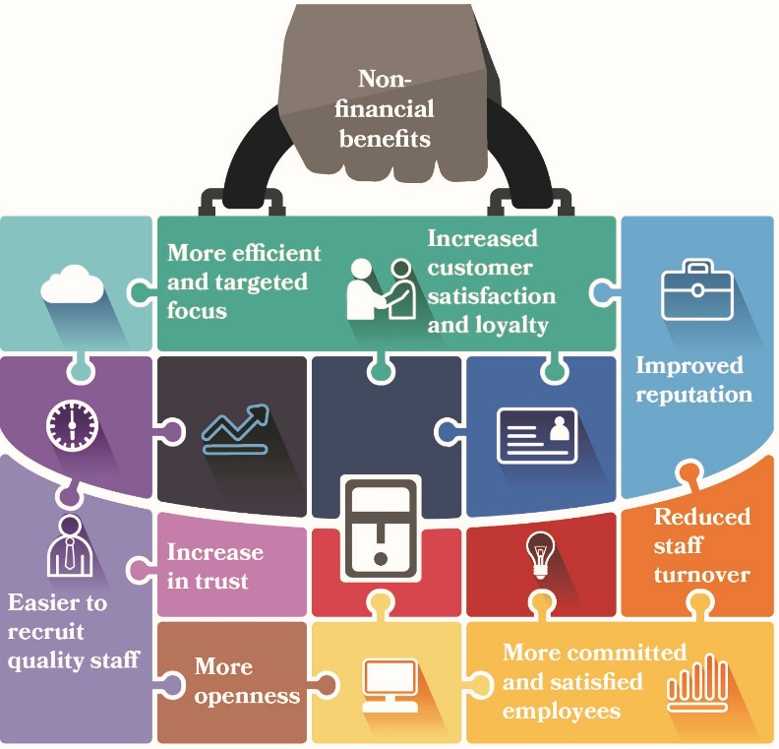
Review the descriptions of the clusters and fourteen criteria to ensure that you understand their focus.
Cluster | Criteria
Cultural Cognisance  This cluster contains five criteria and examines top management’s commitment and role in building and maintaining cultural cognisance. | - Leadership  - Strategic alignment to the external environment  - Market positioning and customer orientation  - People centred practice  - People rewards
Action Through People  This cluster contains six criteria and examines top management’s commitment and role in building and maintaining action through people. | - Investment in people  - Flexible working and diversity  - Strategy and tasks  - The thinking performer  - Loyalty and inclusiveness  - Self-motivation
Performance Outcomes  This cluster contains three criteria and examines top management’s commitment and role in building and maintaining action through people. | - Measurable outputs and target setting  - Added value activities and innovation of processes  - Quality assurance

Scoring the Inventory
- Read each of the six statements listed under each element
- Choose the statement that best describes how you perceive the present situation in your organisation.
Choices range from exceptionally strong performance to total absence of performance for each element. Circle letter next to the statement that matches your perception of the level of performance.
Cluster 1: Cultural Cognisance | Response
Leadership
All top management are directly and actively involved in open leadership, teamwork and decision making that is shared and communicated through the organisation | A
All top management participate in open leadership, team work and decision making that is shared and communicated through the organisation | B
Some top management are directly and actively involved in open leadership, teamwork and decision making that is shared and communicated through the organization | C
Some top management participate in open leadership, teamwork and decision- making that is shared and communicated through the organisation | D
No top management are directly and actively involved in open leadership, teamwork and decision making that is shared and communicated through the organization | E
No top management participate in open leadership, teamwork and decision making that is shared and communicated through the organisation | F
Strategic Alignment and the External Environment
All top management are actively and directly involved in the strategic alignment of operations and tactics and responses to the external environment. | A
All top management participate in the strategic alignment of operations and tactics and responses to the external environment | B
Some top management are directly and actively involved in the strategic alignment of operations and tactics and responses to the external environment | C
Some top management participate in the strategic alignment of operations and tactics and responses to the external environment | D
No top management are directly and actively involved in the strategic alignment of operations and tactics | E
No top management participate in the strategic alignment of operations and tactics and responses to the external environment | F
Market Positioning and Customer Orientation
All top management are directly and actively involved in clear market positioning and customer orientation | A
All top management participate in clear market positioning and customer orientation | B
Some top management are directly and actively involved in clear market positioning and customer orientation | C
Some top management participate in clear market positioning and customer orientation | D
No top management are directly and actively involved in clear market positioning and customer orientation | E
No top management participate in clear market positioning and customer orientation | F
People Centred Practice and Culture
All top management are directly and actively involved in an open, creative, people centred culture | A
All top management participate in an open, creative, people centred culture | B
Some top management are directly and actively involved in an open, creative, people centred culture | C
Some top management participate in an open, creative, people centred culture | D
No top management are directly and actively involved in an open, creative, people centred culture | E
No top management participate in an open, creative, people centred culture | F
People and Rewards
All top management are directly and actively involved in people reward systems | A
All top management participate in people reward systems | B
Some top management are directly and actively in people reward systems | C
Some top management participate in people reward systems | D
No top management are directly and actively in people reward systems | E
No top management participate in people reward systems | F
Cluster 2: Action Through People
Investment in People
All top management are directly and actively involved in the investment in people such as education and training | A
All top management participate in the investment in people such as education and training | B
Some top management are directly and actively involved in the investment in people such as education and training | C
Some top management participate in the investment in people such as education and training | D
No top management are directly and actively involved in the investment in people such as education and training | E
No top management participate in the investment in people such as education and training | F
Flexible Working and Diversity
All top management are directly and actively involved in flexible working and diversity | A
All top management participate in flexible working and diversity | B
Some top management are directly and actively involved in flexible working and diversity | C
Some top management participate in flexible working and diversity | D
No top management are directly and actively involved in flexible working and diversity | E
No top management participate in flexible working and diversity | F
Strategy and Tasks
All top management are directly and actively involved in the transparent alignment of tasks and functional roles to strategic requirements of the organisation | A
All top management participate in the transparent alignment of tasks and functional roles to strategic requirements of the organisation | B
Some top management are directly and actively involved in the transparent alignment of tasks and functional roles to strategic requirements of the organisation | C
Some top management participate in the transparent alignment of tasks and functional roles to strategic requirements of the organisation | D
No top management are directly and actively involved in the transparent alignment of tasks and functional roles to strategic requirements of the organisation | E
No top management participate in the transparent alignment of tasks and functional roles to strategic requirements of the organisation | F
The thinking performer
All top management directly and actively encourage the empowerment of employees such as the ‘thinking performer’ | A
All top management participate in the encouragement of empowerment of employees such as the ‘thinking performer’ | B
Some top management directly and actively encourage the empowerment of employees such as the ‘thinking performer’ | C
Some top management participate in the encouragement of empowerment of employees such as the ‘thinking performer’ | D
No top management are directly and actively involved in the encouragement of the empowerment of employees such as the ‘thinking performer’ | E
No top management participate in the encouragement and empowerment such as the ‘thinking performer’ | F
Loyalty and Inclusiveness
All top management are directly and actively involved in the encouragement of loyalty and inclusiveness | A
All top management participate in the encouragement of loyalty and inclusiveness | B
Some top management are directly and actively involved in the encouragement of loyalty and inclusiveness | C
Some top management participate in the encouragement of loyalty and inclusiveness | D
No top management are directly and actively involved the encouragement of loyalty and inclusiveness | E
No top management participate in the encouragement of loyalty and inclusiveness | F
Self-motivation
All top management are directly and actively involved in the self-motivation of employees | A
All top management participate in the self-motivation of employees | B
Some top management are directly and actively involved in the self-motivation of employees | C
Some top management participate in the self-motivation of employees | D
No top management are directly and actively involved in the self-motivation of employees | E
No top management participate in the self-motivation of employees | F
Cluster 3: Performance Outcomes
Measurable Outputs and Target Setting
All top management are directly and actively involved in measurable outcomes such as benchmarking and setting targets | A
All top management participate in measurable outcomes such as benchmarking and setting targets | B
Some top management are directly and actively involved immeasurable outcomes such as benchmarking and setting targets | C
Some top management participate in measurable outcomes such as benchmarking and setting targets | D
No top management are directly and actively involved in measurable outcomes such as benchmarking and setting targets | E
No top management participate in measurable outcomes such as benchmarking and setting targets | F
Value Added Activities and Innovation of Processes
All top management are directly and actively involved in value added activities such as business re-engineering, cost benefits and innovation of processes | A
All top management participate in value added activities such as business reengineering, cost benefits and innovation of processes | B
Some top management are directly and actively involved value added activities such as business re-engineering, cost benefits and innovation of processes | C
Some top management participate in value added activities such as business re-engineering, cost benefits and innovation of processes and innovation of processes | D
No top management are directly and actively involved value added activities such as business re-engineering, cost benefits and innovation of processes | E
No top management participate in value added activities such as business reengineering, cost benefits and innovation of processes | F
Quality assurance and customer responsive and service
All top management are directly and actively involved in quality assurance, customer responsiveness and service | A
All top management participate in quality assurance, customer responsiveness and service delivery | B
Some top management are directly and actively involved in quality assurance, customer responsiveness and service delivery | C
Some top management participate in quality assurance, customer responsiveness and service delivery | D
No top management are directly and actively involved in quality assurance, customer responsiveness and service delivery | E
No top management participate in quality assurance, customer responsiveness and service delivery | F

Scoring Sheet
To determine the scores on the inventory follow the steps below:
1. For each of the clusters listed on the High Performance Inventory in the left column, find the letter under the heading labelled Response categories that corresponds to the one you choose on the questionnaire.
2. Then circle the number that corresponds to the number you chose.
3. Add up the total of each column and add to the score sheet to determine the score for each cluster and the overall score across all the fourteen criteria.
High Performance Working Clusters |  | Response categories
 |  | A | B | C | D | E | F
Criteria | Cluster 1: Cultural Cognisance
1 | Leadership | 20 | 16 | 12 | 8 | 4 | 0
2 | Strategic alignment and the external environment | 20 | 16 | 12 | 8 | 4 | 0
3 | Market positioning and customer orientation | 20 | 16 | 12 | 8 | 4 | 0
4 | People Centred Practice and culture | 20 | 16 | 12 | 8 | 4 | 0
5 | People and rewards | 20 | 16 | 12 | 8 | 4 | 0
 | Cluster 1: Total response scores
 | Cluster 1: Total response score
 |  | A | B | C | D | E | F
Criteria | Cluster 2: Action Through People
6 | Investment in people | 20 | 16 | 12 | 8 | 4 | 0
7 | Flexible working and diversity | 20 | 16 | 12 | 8 | 4 | 0
8 | Strategy and tasks | 20 | 16 | 12 | 8 | 4 | 0
9 | The thinking performer | 20 | 16 | 12 | 8 | 4 | 0
10 | Loyalty and inclusiveness | 20 | 16 | 12 | 8 | 4 | 0
11 | Self-motivation
 | Cluster 2: Total response scores
 | Cluster 2: Total response score
 |  | A | B | C | D | E | F
Criteria | Cluster 3: Performance Outcomes
12 | Measurable Outputs and target setting | 20 | 16 | 12 | 8 | 4 | 0
13 | Added value activities and innovation of processes | 20 | 16 | 12 | 8 | 4 | 0
14 | Quality assurance and customer responsive and service | 20 | 16 | 12 | 8 | 4 | 0
 | Cluster 3: Total response scores
 | Cluster 3: Total response score

Total response scores
Cluster 1___
Cluster 2___
Cluster 3___
Total overall response score ____

High Performance Working Inventory Interpretation Sheet
Total overall response score range 0-56 A score in this range indicates that an organisation has no awareness of High Performance Working practices and has no involvement in the well being of its employees, its working practices, leadership style, quality assurance and innovation processes. An organisation of this type should focus initially on small project lead initiatives that can yield short term and visible results as a means to ‘buy-in’ the workforce and gain management support and confidence.
Total overall response score range 57-112 A score in this range indicates that an organisation needs to attain more awareness of what High Performance Working means and how it can be applied to their current practices. An organisation in this range needs to address urgently their focus on people issues, working practices and leadership approaches if it is to compete in the current competitive environment.
Total overall response score range 113-168 A score in this range indicates that an organisation has certain criteria in place and the foundations to become a High Performing organisation. It should focus its future attention on the weaker parts of its processes, working environment and leadership approaches to move to the next level of performance.
Total overall response score range 169-224 A score in this range indicates an organisation that has a sound and well-organised approach to the management of its people, processes, working environment and leadership style.
Total overall response score range 225-280 A score in this range indicates an organisation that has high commitment and long vision to its people, processes, working environment and leadership approach. An organisation in this category is best in class.
Total Score: ...............

Key Thoughts to take forward into your strategy development:

