Developing Talent? You’re Probably Missing Vertical Development

Both Horizontal & Vertical Development Are Important
What kind of thinkers do you need in your business? What types of leadership will get you desired results? To answer these questions, you’ve got to be thinking about a different kind of learning.
You’re probably providing all sorts of opportunities for horizontal development — disseminating more knowledge, skills, and information.
But vertical development is entirely different. It’s about more complex and sophisticated ways of thinking. It’s called vertical development because it is based on levels, or stages, of thinking. It involves gaining new perspectives and leadership mindsets needed to make your business strategy work.
For example, managers and groups learn to tackle a problem with inquiry — questions, observation, and reflection — before jumping into advocating, lobbying, or deciding. This opens the door to deeper understanding, greater clarity, more options, and multiple right answers — which are especially needed for leading in complex, uncertain situations. This helps build a more interdependent leadership culture at your organization.

What Is Vertical Development?
Our research has found that these 3 primary conditions support vertical leadership development:
- Heat experiences;
- Colliding perspectives; and
- Elevated sensemaking.
Many well-intentioned leadership development programs fail to deliver lasting results because they hit on only 1 or 2 of the conditions for vertical development. Anyone can provide some value, but it is not until you combine all 3 that development really takes off.

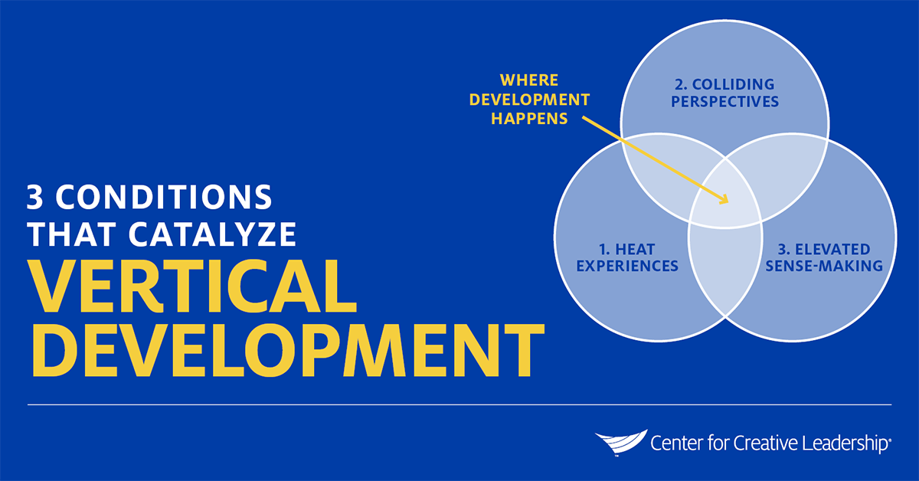

Heat Experiences
Leaders have the opportunity to respond to heat experiences when they face a complex situation that disrupts and disorients their habitual way of thinking. These situations help leaders discover that their current way of making sense of the world is inadequate. As a result, they seek out new and better ways to make sense of their challenge. Heat experiences are the what that initiates development.
Learn more about how to harness heat experiences to accelerate learning in our white paper, Heat Experiences for Development.

Colliding Perspectives
Leaders also have an opportunity to challenge their existing mental models when they’re exposed to people with different worldviews, opinions, backgrounds, and training. These relationships increase the number of perspectives through which leaders experience their world. Colliding experiences are the who that enables development.

Elevated Sensemaking
As leaders process and make sense of these perspectives and experiences, they enter an elevated stage of development. A larger, more advanced worldview emerges and, with time, stabilizes. This is the how that integrates development.

Is Your HR Function Focused on Both Vertical & Horizontal Development?
Is vertical development factored into how your HR function thinks about your talent, your culture, and how people learn and grow? Consider these questions about the perspectives of the human resources/organizational development functions:
- Does our organization understand the difference between horizontal and vertical development? Are both vertical and horizontal development incorporated into our leadership development methods?
- Is our organization aligning our leadership culture to our strategy? Leadership cultures develop through different vertical stages: dependent/conformer, independent/achiever, interdependent/collaborator. Has our team worked out which leadership culture our strategy requires? Are we designing leadership development to match?
- Do we have a good understanding of how leaders make different sense of the world at each of the stages? Whether explicitly or implicitly, is this understanding blended into the way we develop our leaders?
Learn more about how vertical development and organizational culture change are connected in our white paper, Vertical Development: Culture Still Wins Over Strategy.

HR’s Role: Tailoring Development, Both Horizontal & Vertical
Remember, employees come into their roles with different experiences, skills, perspectives, and stages of development. As an internal or external Human Resources leader, your role is to put experience at the center of talent management and tailor development and meet people where they are; not everyone is ready for the same stuff at the same time.
For example, you may emphasize horizontal development for your early-career talent, but you can plant the seeds for vertical development for them, too. Learning from heat experiences, colliding perspectives, and elevated sensemaking can support them through many challenges that first-time managers face.
And for senior or experienced leaders, they need different leadership skills to accelerate performance, so their process of vertical development will likely be more complex and collaborative — but their mindsets or approaches may be more fixed.
There’s an important difference between helping a leader grow and trying to force it, though. Each stage of development, and both horizontal and vertical development, are important. The role of HR is to create the right conditions in which many different people can grow.

Ready to Take the Next Step?
Take our Vertical Leadership Development Audit to see how well your organization understands and is leveraging vertical development. And contact us to learn more about vertical and horizontal development for your talent, tailored to your organization’s unique context and culture. Learn more about our custom Talent Development solutions.

